**Name: Vijay Vishnu p b**

**Roll No:49**

**Batch:b**

**Date:4-4-2022**

**NETWORKING & SYSTEM ADMINISTRATION LAB**

**Experiment No.: 3**

**Aim**

**Procedure**

**37.cp command**

This command is used to copy file

Syntax: cp [option] source destination

Output:

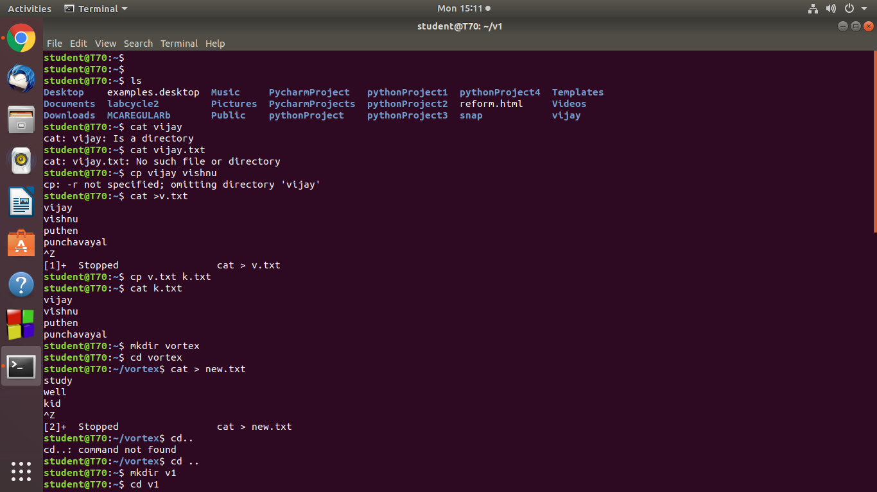

**38.cp –r**

Copies files from one directory to another

Syntax: cp –r source destination

Output:

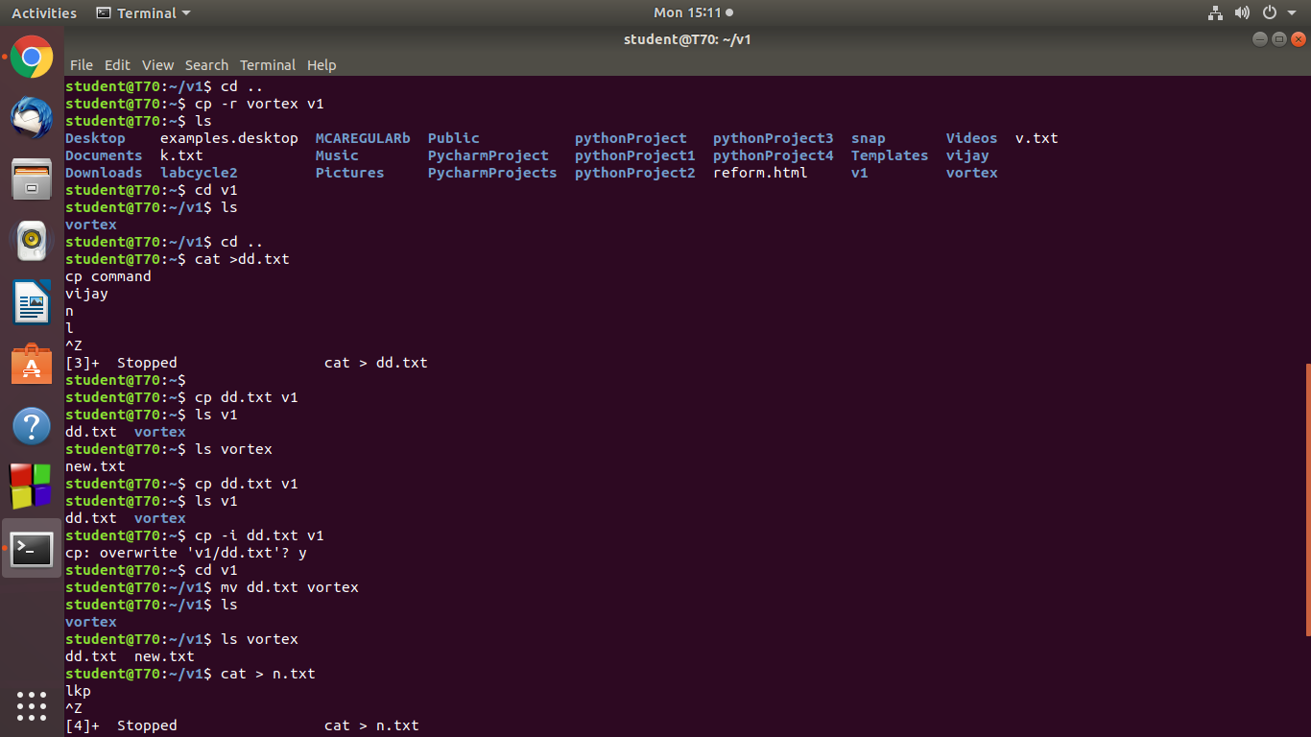

**39.cp –l**

Ask user for conformation before copying the file

Syntax: cp –i

Output:



**40.mv command**

Used to move files from source to destination

Syntax: mv [option] source destination

Output:

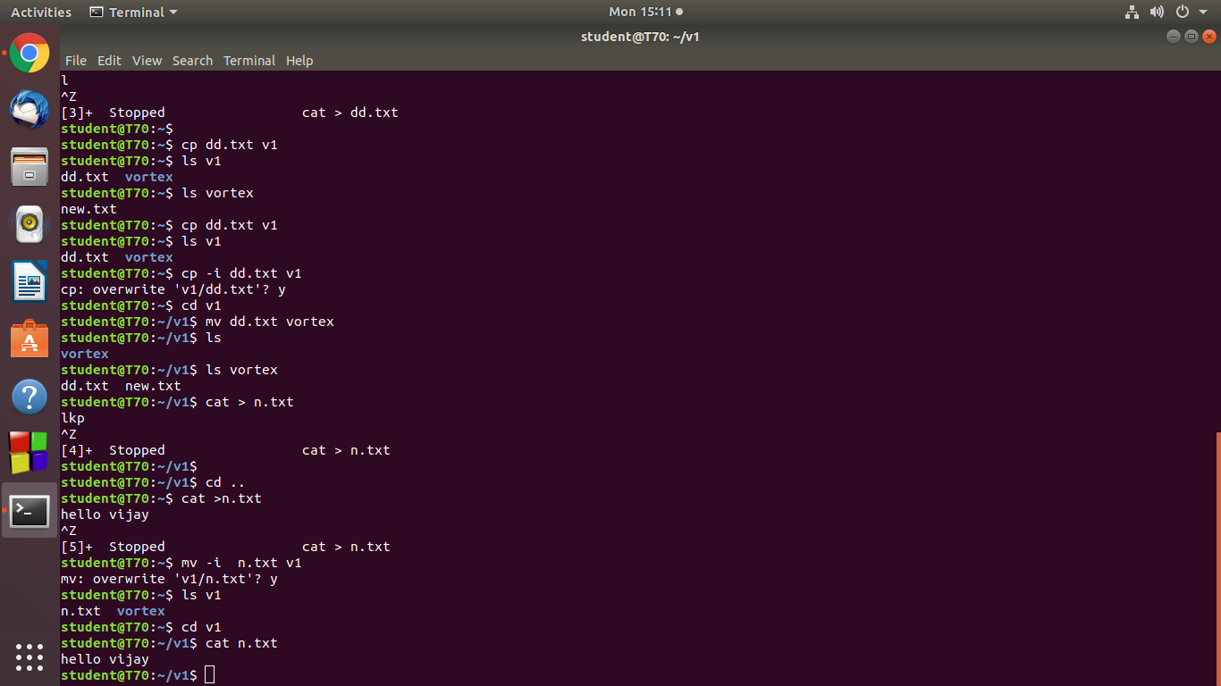

**41. mv –i**

Ask the user for conformation before moving a file

Syntax: mv –i

Output:

